Birds & Bikes May 24th 1-4 pm
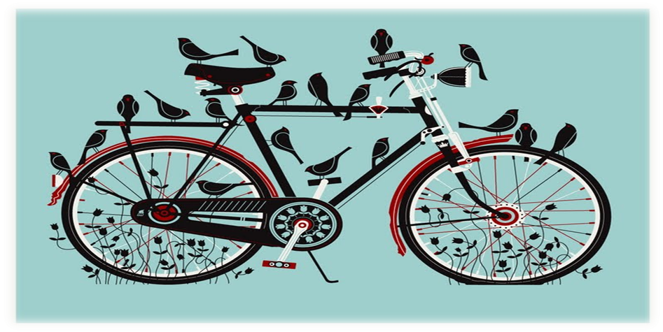
Wachiska Audubon invites you to bike out to Fletcher Prairie to celebrate International Migratory Bird Month with Birds and Bikes at Fletcher Prairie!
- Robert Hanna, Nebraska native and artist, will be sketching migratory birds and their habitats.
- Raptor Recovery will present information on migratory birds and bring some feathered friends.
- Bird activities for children, Families are encouraged to bring a BIRD themed kite to fly!
- Nature walks and bird watching.
The location cannot accommodate many cars, we request that you join us by bike. Fletcher Prairie is east of Lincoln and west of Walton adjacent to the MoPac bike trail. Parking access in Lincoln is off 84th Street just south of the State Farm complex at 84th & ‘O’ Streets and at the Walton Trailhead. You can also jump on the MoPac from many places throughout Lincoln and bike direct to Fletcher’s Prairie.
Questions? Contact Larry or Peg Fletcher at 402-488-4451, or Jessica Umberger at 402-580-3057.
Check out www.nebraskabirdmonth.org to learn about more of Nebraska's IMBM activities in May
